martin.reid@solent.ac.uk

**EPA Assessor Training**

**BSc Digital & Technology Solutions Degree Apprenticeship**

I

integrated Degree

**Reference:**

ST0119

**Version:**

1.1

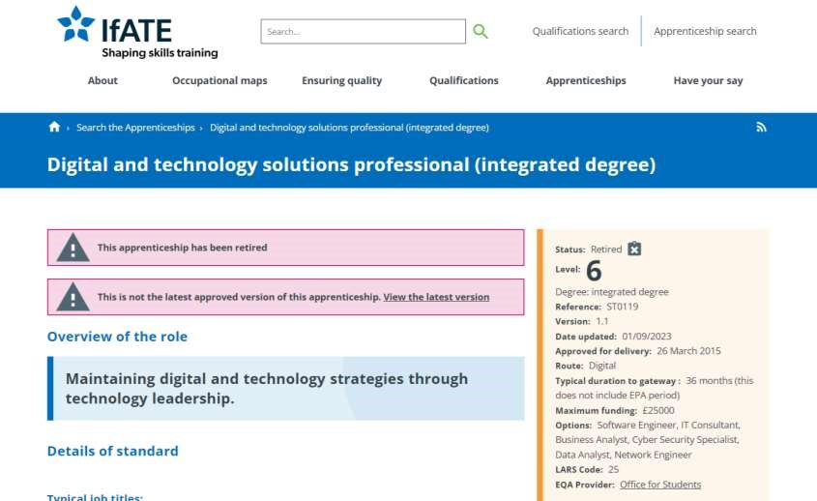

**INSTITUTE FOR APPRENTICESHIPS, 2015**

.

*Digital and technology solutions professional (integrated degree)*

[

viewed 18 October 2024]. Available from:

[p](https://www.instituteforapprenticeships.org/apprenticeship-standards/digital-and-technology-solutions-professional-integrated-degree-v1-1)

[https://www.instituteforapprenticeships.org/apprenticeshi](https://www.instituteforapprenticeships.org/apprenticeship-standards/digital-and-technology-solutions-professional-integrated-degree-v1-1)

[-](https://www.instituteforapprenticeships.org/apprenticeship-standards/digital-and-technology-solutions-professional-integrated-degree-v1-1)

[l](https://www.instituteforapprenticeships.org/apprenticeship-standards/digital-and-technology-solutions-professional-integrated-degree-v1-1)

[standards/digita](https://www.instituteforapprenticeships.org/apprenticeship-standards/digital-and-technology-solutions-professional-integrated-degree-v1-1)

[-](https://www.instituteforapprenticeships.org/apprenticeship-standards/digital-and-technology-solutions-professional-integrated-degree-v1-1)

[d](https://www.instituteforapprenticeships.org/apprenticeship-standards/digital-and-technology-solutions-professional-integrated-degree-v1-1)

[an](https://www.instituteforapprenticeships.org/apprenticeship-standards/digital-and-technology-solutions-professional-integrated-degree-v1-1)

[-](https://www.instituteforapprenticeships.org/apprenticeship-standards/digital-and-technology-solutions-professional-integrated-degree-v1-1)

[y](https://www.instituteforapprenticeships.org/apprenticeship-standards/digital-and-technology-solutions-professional-integrated-degree-v1-1)

[technolog](https://www.instituteforapprenticeships.org/apprenticeship-standards/digital-and-technology-solutions-professional-integrated-degree-v1-1)

[-](https://www.instituteforapprenticeships.org/apprenticeship-standards/digital-and-technology-solutions-professional-integrated-degree-v1-1)

[s](https://www.instituteforapprenticeships.org/apprenticeship-standards/digital-and-technology-solutions-professional-integrated-degree-v1-1)

[solution](https://www.instituteforapprenticeships.org/apprenticeship-standards/digital-and-technology-solutions-professional-integrated-degree-v1-1)

[-](https://www.instituteforapprenticeships.org/apprenticeship-standards/digital-and-technology-solutions-professional-integrated-degree-v1-1)

[l](https://www.instituteforapprenticeships.org/apprenticeship-standards/digital-and-technology-solutions-professional-integrated-degree-v1-1)

[professiona](https://www.instituteforapprenticeships.org/apprenticeship-standards/digital-and-technology-solutions-professional-integrated-degree-v1-1)

[-](https://www.instituteforapprenticeships.org/apprenticeship-standards/digital-and-technology-solutions-professional-integrated-degree-v1-1)

[d](https://www.instituteforapprenticeships.org/apprenticeship-standards/digital-and-technology-solutions-professional-integrated-degree-v1-1)

[integrate](https://www.instituteforapprenticeships.org/apprenticeship-standards/digital-and-technology-solutions-professional-integrated-degree-v1-1)

[-](https://www.instituteforapprenticeships.org/apprenticeship-standards/digital-and-technology-solutions-professional-integrated-degree-v1-1)

[d](https://www.instituteforapprenticeships.org/apprenticeship-standards/digital-and-technology-solutions-professional-integrated-degree-v1-1)

[e](https://www.instituteforapprenticeships.org/apprenticeship-standards/digital-and-technology-solutions-professional-integrated-degree-v1-1)

[gre](https://www.instituteforapprenticeships.org/apprenticeship-standards/digital-and-technology-solutions-professional-integrated-degree-v1-1)

[e](https://www.instituteforapprenticeships.org/apprenticeship-standards/digital-and-technology-solutions-professional-integrated-degree-v1-1)

[-](https://www.instituteforapprenticeships.org/apprenticeship-standards/digital-and-technology-solutions-professional-integrated-degree-v1-1)

[v](https://www.instituteforapprenticeships.org/apprenticeship-standards/digital-and-technology-solutions-professional-integrated-degree-v1-1)

[1](https://www.instituteforapprenticeships.org/apprenticeship-standards/digital-and-technology-solutions-professional-integrated-degree-v1-1)

[-](https://www.instituteforapprenticeships.org/apprenticeship-standards/digital-and-technology-solutions-professional-integrated-degree-v1-1)

[1](https://www.instituteforapprenticeships.org/apprenticeship-standards/digital-and-technology-solutions-professional-integrated-degree-v1-1)

BSc Digital &

T

echnology

S

olutions

P

rofessional

(

ST0119

-

2015

-

version

:

1.1)

**KSB**

**Knowledge, Skills & Behaviours**

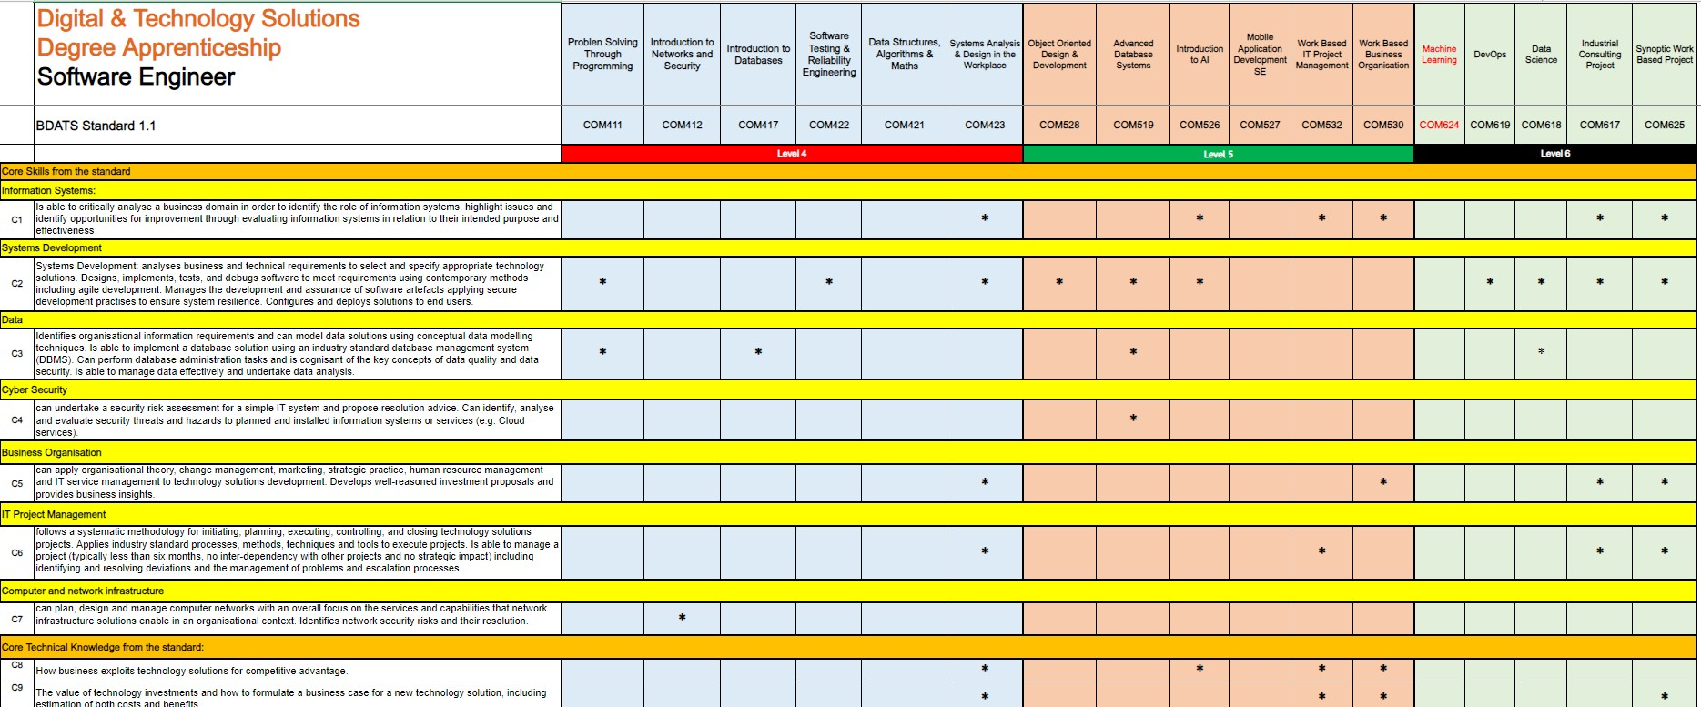

Knowledge, Skills & Behaviours (KSBs) Mapping

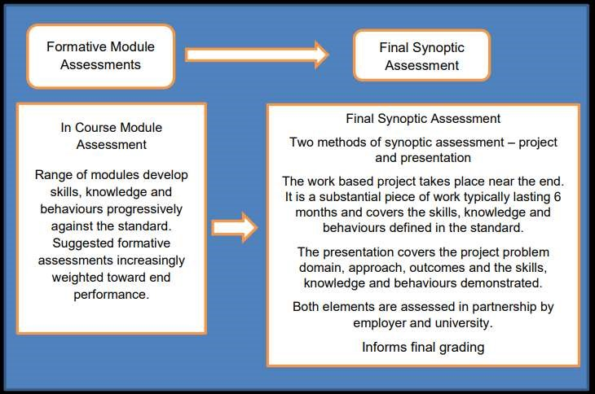

**INSTITUTE FOR APPRENTICESHIPS, 2015b**

.

*DIGITAL INDUSTRIES*

*-*

*ASSESSMENT PLAN DIGITAL & TECHNOLOGY SOLUTIONS PROFESSIONAL BSC (Hons) Digital & Technology Solutions*

. instituteforapprenticeships.org.

Institute for Apprenticeships [viewed 18 October 2024]. Available from:

[https://www.instituteforapprenticeships.org/media/1073/digital_and_technology_solutions_professional.pd](https://www.instituteforapprenticeships.org/media/1073/digital_and_technology_solutions_professional.pdf)

[f](https://www.instituteforapprenticeships.org/media/1073/digital_and_technology_solutions_professional.pdf)

BSc Digital &

T

echnology

S

olutions

P

rofessional

(

ST0119

-

2015

-

version

:

1.1)

# Overall Assessment Strategy

The assessment strategy for the **Degree Apprenticeship** includes a balanced mix of essays, reports, practical exercises, coursework, and tests. These are mapped to each module of the **BSc Digital & Technology Solutions Degree Apprenticeship** to assess the development of Knowledge, Skills, and Behaviours (KSBs). The End Point Assessment (EPA) consists of a Synoptic Project and Presentation.

**INSTITUTE FOR APPRENTICESHIPS, 2015b**. *DIGITAL INDUSTRIES -ASSESSMENT PLAN DIGITAL & TECHNOLOGY SOLUTIONS PROFESSIONAL BSC (Hons) Digital & Technology Solutions*. instituteforapprenticeships.org. Institute for Apprenticeships [viewed 18 October 2024]. Available from: <https://www.instituteforapprenticeships.org/media/1073/digital_and_technology_solutions_professional.pdf>

**Portfolio Mapping**

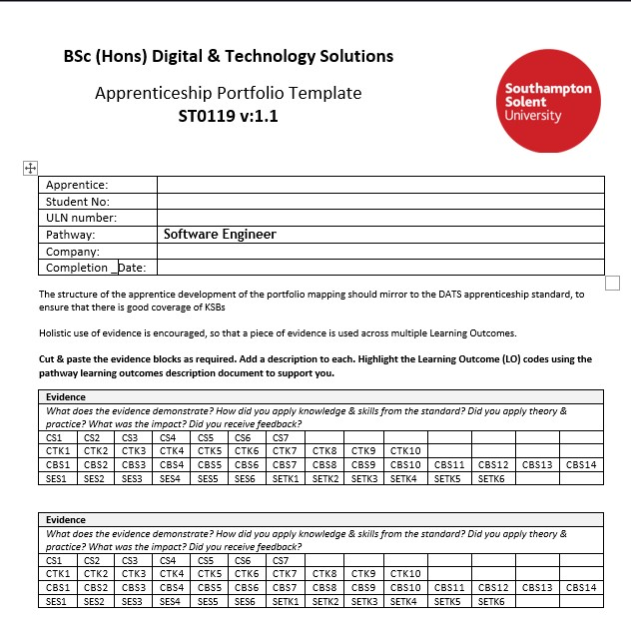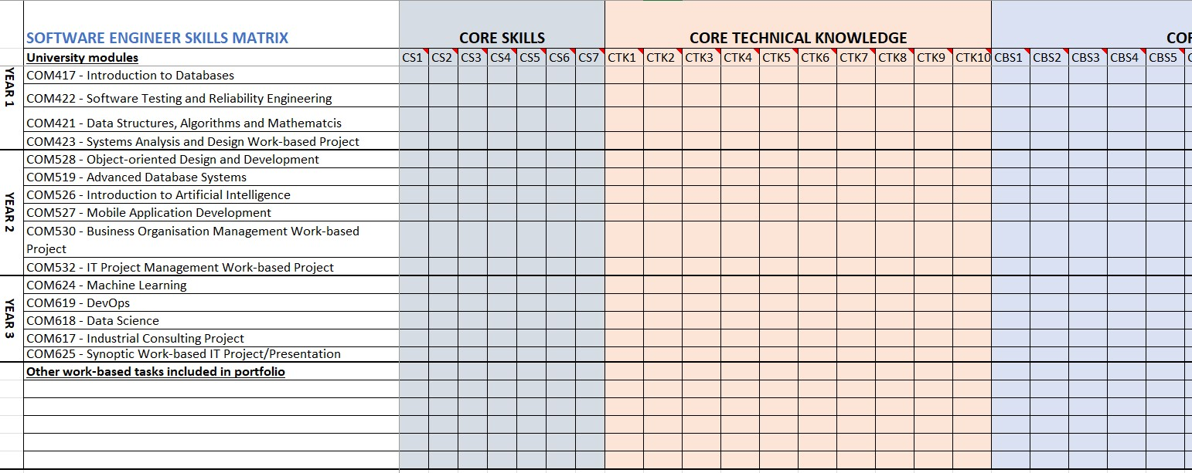

**Synoptic Project**



[image: Ian Mation](https://ilitratophotography.wordpress.com/2011/08/30/the-cne-midway-fun/#jp-carousel-130)

[g](https://ilitratophotography.wordpress.com/2011/08/30/the-cne-midway-fun/#jp-carousel-130)

**Project Selection**

The final

**Synoptic Project**

is a substantial piece of work,

typically taking around

**6**

**months**

to undertake alongside

the apprentices' normal duties to their employer and will

include

**doing practical work and report writing**

.

**The Project Aim**

The project should

**add value to your**

**organisation**

, and it needs to hit the

pathway learning outcomes (KSBs) that are

in the apprenticeship standard.

[Digital and technology solutions professional (integrated degree) / Institute for Apprenticeships and Technical Educatio](https://www.instituteforapprenticeships.org/apprenticeship-standards/digital-and-technology-solutions-professional-integrated-degree-v1-1)

[n](https://www.instituteforapprenticeships.org/apprenticeship-standards/digital-and-technology-solutions-professional-integrated-degree-v1-1)

**Project Sign Off**

The

**project topic must be discussed,**

**agreed upon, and approved**

by the

University, the Apprentice, and the

company/manager before the project

begins

**using the project outline form**

.

[Digital and technology solutions professional (integrated degree) / Institute for Apprenticeships and Technical Educatio](https://www.instituteforapprenticeships.org/apprenticeship-standards/digital-and-technology-solutions-professional-integrated-degree-v1-1)

[n](https://www.instituteforapprenticeships.org/apprenticeship-standards/digital-and-technology-solutions-professional-integrated-degree-v1-1)

**AE1**

**–**

**Report 1**

**-**

**10**

**%**

**(**

**1500**

**words**

**)**

The initial phase of the project focuses on defining its scope and

purpose, including any relevant business, ethical, legal, and professional

considerations. This phase also involves reviewing existing literature and

developing a project plan. Feasibility and requirements are assessed

during this stage as well

.

**AE2**

**–**

**Report 1**

**-**

**70**

**%) (10,000 words**

**)**

The final project report should present a narrative of the project from

inception to completion, aligned with the relevant Knowledge, Skills, and

Behaviours (KSBs). It should outline the approaches taken, the rationale for

their selection, and assess the project’s outputs in terms of their suitability

for purpose. The report should also include conclusions, a critical review of

the overall process, and recommendations for future development.

1.

Title Page

2.

Acknowledgements

3.

Summary

4.

Contents

5.

List of Figures

6.

Project Specification/Requirements

7.

Methodology/Evaluation

•

Professional, Legal and Ethical issues

•

Project Management

8.

Design

,

implementation

9.

Testing & Results

10.

Conclusions

11.

Recommendations for further Work and/or discussion

12.

References List

13.

Appendices

**Final Report Structure**

**AE3**

**–**

**Demo/Presentation**

**-**

**2**

**0**

**%**

**(25**

**-**

**30**

**mins**

**)**

To support your Project Report, you will need to

give a presentation/demonstration of your project.

**Gateway**

Upon completion of the on

-

programme off

-

the

-

job training, a

**Gateway**

meeting will be arranged

to ensure that the apprentice has completed and

passed all modules and is ready to progress to the

End Point Assessment (EPA).

This meeting will also verify that all required

documents, including the off

-

the

-

job training

tracker, portfolio mapping and employer

reference, have been completed.

**EPA**

**End Point Assessment**



**EPA Presentation**

**-**

**1**

**hour**

*"The presentation is a*

***structured***

***discussion between the***

***apprentice***

***and their***

***university lecturer/s***

***and***

***employer***

***, focusing on the***

***outcomes of the synoptic project***

*.*

*It covers both what the apprentice*

*has done, the standard of their*

*work, and how they have done it."*

The Presentation (P.7 2.2.3)

**INSTITUTE FOR APPRENTICESHIPS.ORG, 2015**

. DIGITAL INDUSTRIES

-

ASSESSMENT PLAN DIGITAL & TECHNOLOGY SOLUTIONS PROFESSIONAL BSC (Hons) Digital & Technology Solutions

[

viewed 14 February 2025]. Available from:

[https://www.instituteforapprenticeships.org/media/1073/digital_and_technology_solutions_professional.pd](https://www.instituteforapprenticeships.org/media/1073/digital_and_technology_solutions_professional.pdf)

[f](https://www.instituteforapprenticeships.org/media/1073/digital_and_technology_solutions_professional.pdf)

**Tutor**

**Employer**

**EPA Assessor**

# EPA Assessor

**T**he EPA assessor will already have access to the Apprentice’s Synoptic Project Report. They will need to formulate questions about the project, either using the provided question bank or by creating their own.

The Assessor will ask between 4 and 6 questions. They can also ask follow-up questions, provided that all questioning and discussion are completed within the allocated time frame

# Employer Reference

The assessment of the Synoptic Project should include the **employer’s evaluation against the common criteria.** This will be documented in the **Employer's Reference**, completed and **signed off before the EPA Presentation.**

**This will be discussed when working out the final grade and feedback in the assessment meeting following the EPA presentation**

**Support Tutor Assessment**

Support tutor will also evaluate and assess the Apprentice

Synoptic Report and Presentation and will have available

appropriate documentation to discuss and help finalise final

grade at the EPA assessment meeting following on from the

EPA Presentation.

**This will fill fulfil the university’s regulations on having**

**two graders on a 40**

**-**

**Credit module assessment**

The EPA Presentation serves to demonstrate how the apprentice has approached and achieved the project. It aims to explore the apprentices' process including problem solving and overall work, and must:

* Review the project's aims and results.
* Demonstrate the standard of work.
* Explain the approach and address issues.
* Clarify any questions from **university/employer**.
* Confirm interpersonal and behavioural skills.
* Be **assessed as part of the overall project assessment** and inform the degree award.

**Project Presentation Format**

* Can be conducted face-to-face or online (Photo ID required)
* A **conflict-of-interest** form must be completed to confirm that the Apprentice and Assessor do not know each other
* The Apprentice will **present for 25-30 minutes**, followed by a **Q&A session** within a **1-hour time slot**
* **The Apprentice will leave meeting**
* **Assessor, Tutor and Employer** collaboratively finalise grade and feedback (Report & Feedback)

# EPA Presentation - 1 hour



**Assessment**

**& Grading**

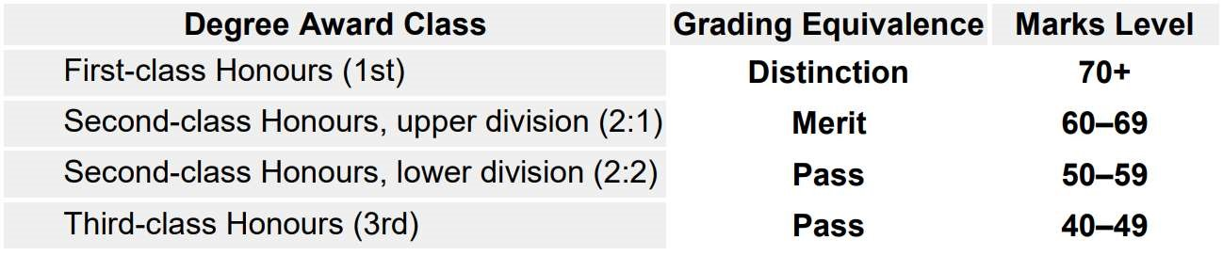

The Honours degree award and classification is based on

**a weighted average mark of the**

**assessed work the apprentice has completed**

. The

**Synoptic Project (40 credits)**

contributes

greatly to the final year marks. Apprentices will be graded using Honours degree

classifications for English universities. The national

**degree award outcomes are shown below**

**with apprenticeship grading equivalence**

. These typically are as follows:

**Assessment and Grading**

Southampton Solent

University



**Grade Criteria**

**& Calculation**

Southampton Solent

University

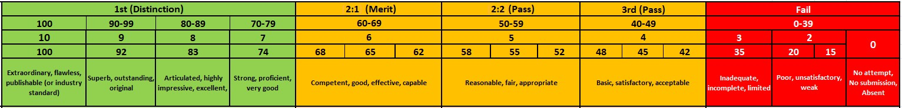

**Numeric Grade Marks**

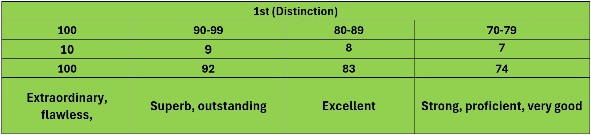

**Extraordinary 100%**

:

This grade is for work that is truly exceptional in every

way. The project demonstrates groundbreaking innovation and has a

significant impact on the organisation. The report is meticulously detailed,

and the presentation is highly engaging and professional.



**Outstanding 92%**

:

This grade is for work that is significantly above average.

The project shows a high level of creativity and effectiveness. The report is

thorough and well

-

organised, and the presentation is clear and confident.



**Excellent 83%**

:

This grade indicates very high

-

quality work. The project is

well

-

executed and meets all the objectives effectively. The report is

comprehensive and well

-

written, and the presentation is polished and

informative.



**Excellent 83%**

:

This grade indicates very high

-

quality work. The project is

well

-

executed and meets all the objectives effectively. The report is

comprehensive and well

-

written, and the presentation is polished and

informative.



**Strong/Very Good 74%**

:

This grade is for work that is above average. The

project is solid and achieves its goals. The report is detailed and clear, and

the presentation is well

-

prepared and delivered.

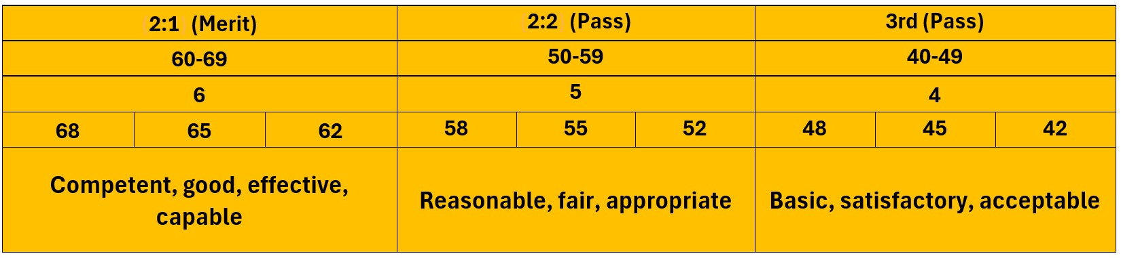

**Competent, good, effective, capable 60**

**-**

**69**

**%**

:

This grade is for work that

meets the basic requirements. The project is adequately executed and

achieves its main objectives. The report is clear and covers the necessary

points, and the presentation is satisfactory.



**Reasonable, fair, appropriate 50**

**-**

**59**

**%**

:

This grade is for work that is

acceptable but has some shortcomings. The project meets most objectives

but lacks depth or thoroughness. The report is adequate but may be missing

some details, and the presentation is clear but not particularly engaging..



**Basic, satisfactory, acceptable 40**

**-**

**49**

**%**

:

This grade is for work that meets the

minimum requirements. The project is completed but lacks depth and

impact. The report covers the basics but is not detailed, and the

presentation is clear but lacks enthusiasm.

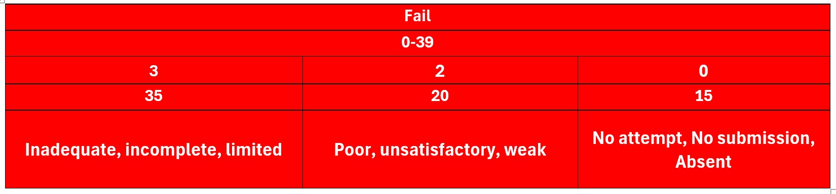

**Inadequate, incomplete, limited 30**

**-**

**39**

:

This grade is for work that does not

meet the required standards. The project fails to achieve its main objectives.

The report is incomplete or poorly organised, and the presentation is

unclear or unprofessional.



**Poor, unsatisfactory, weak 20**

**-**

**39**

**%**

:

This grade is for work that is

significantly below the required standards. The project is poorly executed

and has little to no impact. The report is very incomplete or poorly written,

and the presentation is unclear and unengaging.



**Inadequate, incomplete, limited 30**

**-**

**39**

:

This grade is for work that does not

meet the required standards. The project fails to achieve its main objectives.

The report is incomplete or poorly organised, and the presentation is

unclear or unprofessional.

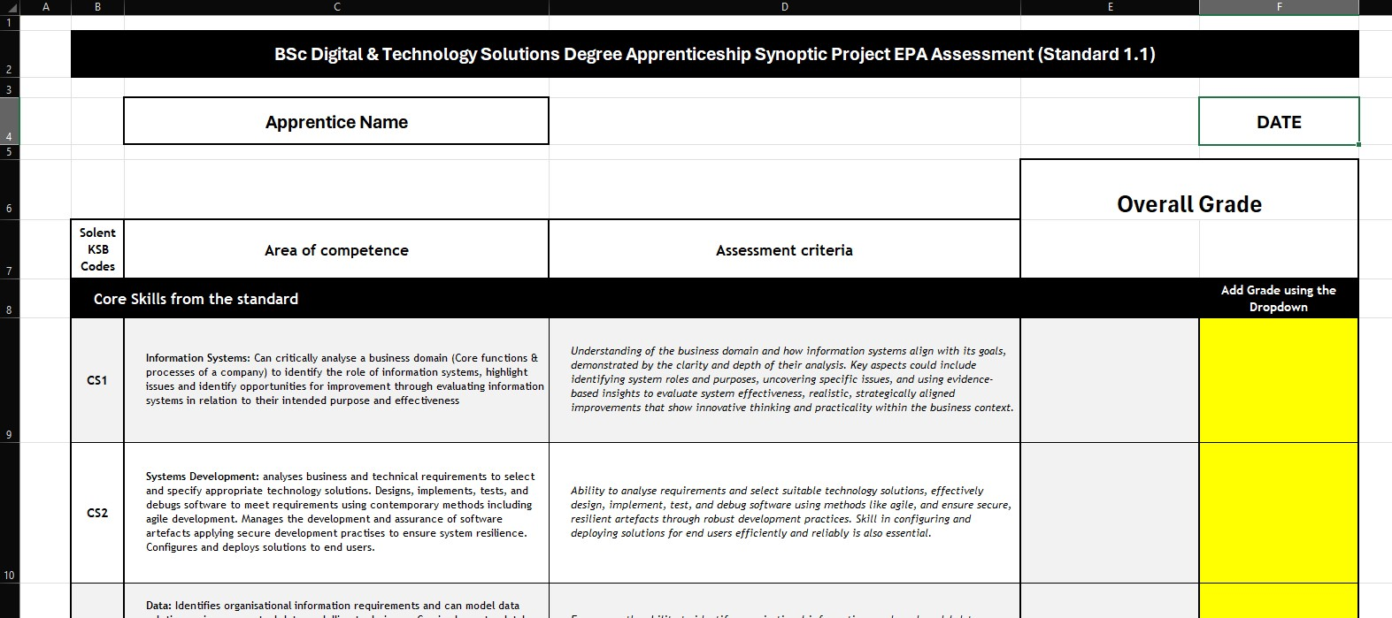

**Thank You**